

**ECEN 5053-003 Homework Assignment**

Course Name: Embedding Sensors and Actuators

Corresponding Module: C3M3

Week Number: 11

Module Name: Position Sensors

Note: Correct answer is in Blue Font

Submitted By: Poorn Mehta

Part 1: Each question is worth 8 points.

1. Answer the following questions about capacitive proximity detectors.

A.1 What is the sensing face of a capacitive proximity detector? How does the size of the sensing face affect the sensing distance and why?

Answer: For the capacitive proximity sensor, **sensing face is the surface of the proximity sensor parallel to the target, from which operating distance/range is measured**, along the reference axis [**[1]**](http://www.softnoze.com/glossary-s.cfm) .

**The size of the sensing face is defined by the electrodes. The larger the measuring electrode, the larger the electrical field and the greater the sensing distance** [**[2 – page 8]**](https://www.baumer.com/de/de/produktubersicht/objekterkennung/kapazitive-sensoren/c/medias/__secure__/Baumer_Capacitive_Sensors_EN_1802_CT_11198937.pdf?mediaPK=8899180396574) .

A.2 How does a capacitive proximity detector manifest temperature drift?

Answer: **Due to the temperature drift, the effective sensing distance Sr can change in relation to the nominal sensing distance Sn by the specified range** [**[3 – page 8]**](https://www.baumer.com/de/de/produktubersicht/objekterkennung/kapazitive-sensoren/c/medias/__secure__/Baumer_Capacitive_Sensors_EN_1802_CT_11198937.pdf?mediaPK=8899180396574) **.**

A.3 How are Baumer capacitive detection sensors protected against users supplying the incorrect input voltage or current?

Answer: Along with residual ripple of maximum 10%, the Baumer capacitive detection sensors are **protected against voltage peak, short circuits, and reverse polarity** [**[4 – page 8]**](https://www.baumer.com/de/de/produktubersicht/objekterkennung/kapazitive-sensoren/c/medias/__secure__/Baumer_Capacitive_Sensors_EN_1802_CT_11198937.pdf?mediaPK=8899180396574) .

A.4 What is a standard target for a capacitive detection sensor?

Answer: The standard target is a predefined part used for comparative measurement of sensing distances and scanning ranges. For the capacitive detection sensor, **a grounded 1mm thick square made up of Fe 360 (ST 37) is used**. Also, The side length corresponds to either the diameter of the sensing face or the triple nominal sensing distance Sn, the respectively higher value being definitive [**[5 – page 9]**](https://www.baumer.com/de/de/produktubersicht/objekterkennung/kapazitive-sensoren/c/medias/__secure__/Baumer_Capacitive_Sensors_EN_1802_CT_11198937.pdf?mediaPK=8899180396574) .

A.5 What is the difference between the usable sensing distance and effective sensing distance of a capacitive proximity switch?

Answer: **Effective sensing distance** of an individual proximity switch which is **measured at a defined temperature, voltage and installation conditions**. For capacitive proximity switches it must be between **90% and 110% of the nominal sensing distance** at 23±5 °C. However, **usable sensing distance** of an individual proximity switch is **measured over the temperature range and at a supply voltage of 85% and 110% of the rated value**. For capacitive proximity switches it must be between **80% and 120% of the effective sensing distance** [**[6 – page 9]**](https://www.baumer.com/de/de/produktubersicht/objekterkennung/kapazitive-sensoren/c/medias/__secure__/Baumer_Capacitive_Sensors_EN_1802_CT_11198937.pdf?mediaPK=8899180396574) .

A.6 What is the difference in a capacitive detection switch between a PNP output and an NPN output?

Answer: The load resistance of PNP sensors is between output and 0 V (pull-down resistance), while load resistance of NPN sensors is between +Vs and output (pull-up resistance). As a result, **the PNP output is connected to the positive voltage supply during switching (positive switching output), whereas the NPN output is connected to the negative voltage supply during switching (negative switching output)** [**[7 – page 12]**](https://www.baumer.com/de/de/produktubersicht/objekterkennung/kapazitive-sensoren/c/medias/__secure__/Baumer_Capacitive_Sensors_EN_1802_CT_11198937.pdf?mediaPK=8899180396574).

A.7 What is the difference between normally open (NO) and normally closed (NC) contacts in a capacitive detection switch?

Answer: During damping with an object, sensors with normally open function establish contact connections (Uz = high), while sensors with normally closed function disconnect connections (Uz = low) [**[8 – page 12]**](https://www.baumer.com/de/de/produktubersicht/objekterkennung/kapazitive-sensoren/c/medias/__secure__/Baumer_Capacitive_Sensors_EN_1802_CT_11198937.pdf?mediaPK=8899180396574) .

1. Answer the following questions about magnetic position detectors.

B.1 What is the difference between the magnetic operating point and the magnetic release point in a hall effect switch?

Answer: BOP – Magnetic operating point: **the level of a strengthening magnetic field at which a Hall device switches on**. The resulting state of the device output depends on the individual device electronic design. BRP – Magnetic release point: **the level of a weakening magnetic field at which a Hall device switches off.** The resulting state of the device output depends on the individual device electronic design [**[9]**](https://www.allegromicro.com/en/Design-Center/Technical-Documents/Hall-Effect-Sensor-IC-Publications/Omnipolar-Switch-Hall-Effect-IC-Basics.aspx) .

B.2 What is the difference between the output fall time and output rise time in a hall effect switch?

Answer: **Fall Time** – the time it takes for the hall effect switch to go **from 90% of the voltage level to the 10% of the voltage level**, while **Rise Time** – is the time taken for the hall effect switch to go **from 10% of the voltage level to the 90% of the voltage level** [**[10]**](http://www.ti.com/lit/ds/symlink/drv5023.pdf) .

B.3 What does the term “Single Axis Sensitivity” mean in the context of an LVDT?

Answer: An LVDT **responds to motion of the core along the coil's axis**, but is generally **insensitive to cross-axis motion of the core or to its radial position**. Thus, an LVDT can usually function without adverse effect in applications involving misaligned or floating moving members, and in cases where the core does not travel in a precisely straight line [**[11]**](https://www.te.com/usa-en/industries/sensor-solutions/insights/lvdt-tutorial.html) .

B.4 Why is an LVDT an absolute output device? What is the advantage of such a device?

Answer: Small variations in the position of the core of the LVDT will lead to different output voltages which can be related to different position values. **Since different voltage levels relate to different position values, the output of a LVDT is absolute** [**[12]**](http://www.heidenhain.us/addl-materials/enews/stories_1012/tech_tidbit-el.php) . The key **advantage** of this is that **in the event of loss of power, the position data being sent from the LVDT will not be lost**. When the measuring system is restarted, the LVDT's output value will be the same as it was before the power failure occurred [**[13]**](https://www.te.com/usa-en/industries/sensor-solutions/insights/lvdt-tutorial.html) .

B.5 The LVDT is known as a fast-dynamic response sensor. What are two limiting factors to its speed of response?

Answer: **(1) Inertial effects of the core’s light mass (2) Characteristics of signal conditioner being used** [**[14]**](https://www.te.com/usa-en/industries/sensor-solutions/insights/lvdt-tutorial.html) **.**

B.6 What does null point repeatability mean? What applications are well suited for an LVDT given its null point repeatability?

Answer: **Null point repeatab**ility means that the **location of an LVDT's intrinsic null point is extremely stable and repeatable**, even over its very wide operating temperature range. Therefore, it is very well suitable for **closed loop control systems** and **high-performance servo balance instruments** [**[15]**](https://www.te.com/usa-en/industries/sensor-solutions/insights/lvdt-tutorial.html) **.**

B.7 In an LVDT what is the phase angle of the output relative to the primary excitation voltage used for?

Answer: In an LVDT, the phase angle of AC output voltage, referenced to the primary excitation voltage, stays constant until the center of the core passes the null point, where the phase angle changes abruptly by 180°. **This 180° phase shift can be used to determine the direction of the core from the null point by means of appropriate circuitry** [**[16]**](https://www.te.com/usa-en/industries/sensor-solutions/insights/lvdt-tutorial.html) **.**

C. This question refers to the operating states of capacitive detection switches.

C.1 What is the direction of current flow and what is the state of the LED when the switch defined by the diagram below detects an object?

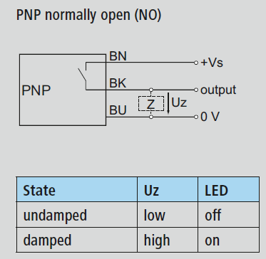

Answer: This is Normally Open switch. So, it will close when object is detected. Therefore, output = source voltage. Direction of current – **From output pin to 0V pin (BK to BU) through Z. LED – ON.**

C.2 What is the direction of current flow and what is the state of the LED when the switch defined by the diagram below detects an object?

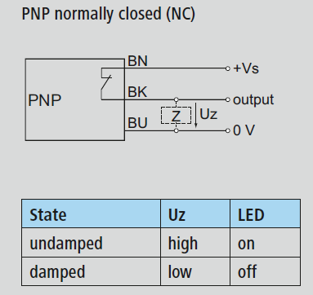

Answer: This is Normally Closed switch. So, it will open when object is detected. Therefore, output = 0V (pull down resistor). Direction of current – **No current flow in the circuit. LED – OFF.**

C.3 What is the direction of current flow and what is the state of the LED when the switch defined by the diagram below detects an object?

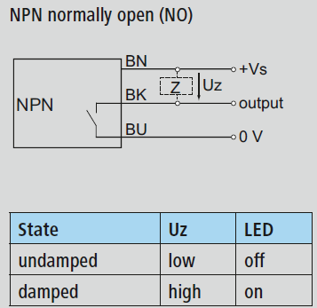

Answer: This is Normally Open switch. So, it will close when object is detected. Therefore, output = 0V. Direction of current – **From source voltage pin to output pin (BN to BK) through Z. LED – ON.**

C.4 What is the direction of current flow and what is the state of the LED when the switch defined by the diagram below detects an object?

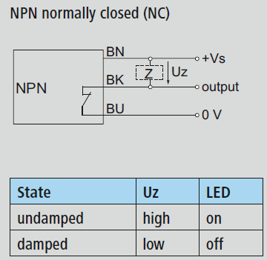

Answer: This is Normally Closed switch. So, it will open when object is detected. Therefore, output = source voltage (pull up resistor). Direction of current – **No current flow in the circuit. LED – OFF.**

1. How does the ungrounded capacitive position sensor differ in its method of detecting an object versus the grounded sensor?

Answer: **Ungrounded** capacitive position sensor has **one electrode** of the capacitor **inside the sensor** – which **does nothing until a conductive object passes by. When that happens, the AC current of constant frequency will flow through the sensor** – where the **conductive object will work as the other electrode**. Therefore, only when the object is present – the voltage across the capacitor takes place. For the **grounded** capacitive position sensor **both the measuring and ground electrodes of the capacitor are located inside the sensor.** A known **measuring field extends into** the volume occupied by the **non-conductive object**. The **capacitor senses a dielectric different than air, which leads to a change in capacitance**.

1. A Go to Google Patents ([www.patents.google.com](http://www.patents.google.com)) and download US patent 6,777,958. Read the patent, and create a series of bullet points that explain how the sensor in this patent detects capacitance.

Answer:

* The sensor includes a capacitive stripe that changes the its own capacitance with respect to the distance of an object.
* When there is no object in the range of this capacitive stripe, its capacitance stays at a constant (non-zero) value – which can be interpreted as an offset.
* To detect this capacitance, the patented innovation uses a variable Radio Frequency oscillator.
* As the name suggests, the frequency of this oscillator can be varied depending upon the circuit arrangement.
* Also, the innovation makes use of some other components such as a local oscillator which generate Radio Frequency waves at a fixed (but can be set to some alternate fixed value as well) frequency, a mixer, low pass filter etc.
* The local oscillator is preferably set at frequency of 925MHz.
* When there is no object in the range of detection of capacitive stripe – it can be interpreted as a steady state situation with a fixed offset in capacitance.
* This stripe – is preferably connected to the variable Radio Frequency oscillator through a series capacitor – which creates a capacitor divider to reduce the sensitive (which could be extremely high – to an extent that it can’t be used to stably).
* In the steady state situation, the variable Radio Frequency oscillator is configured to have a fixed frequency which is somewhat lesser than the local oscillator frequency. The patent recommends using 3MHz of difference – thus running variable Radio Frequency oscillator at 922MHz.
* When some object moves in the range of detection of the capacitive stripe – it increases its own capacitance.
* This will result in further reduction of variable oscillator’s output frequency.
* The mixer is fed two different frequencies – one is from local oscillator that is fixed, and another is from variable oscillator which changes the output in accordance with the input capacitance.
* The output of mixer will contain 2 frequencies – one will be the sum of two inputs – and another will be the difference of them.
* Since in this application, a direct difference between two frequencies is more useful – as it can be directly correlated to the actual capacitance values of the capacitive stripe – a low pass filter is used.
* This will cause the really high frequency – that is the sum of local and variable oscillators – to be dropped.
* Since the output of low pass filter is just the difference of two oscillator outputs, the increase in capacitance – will result in increase of this output.
* This is effectively end of the capacitance detection portion, which can be used in number of ways in further stages.

1. What is the difference between a unipolar and a bipolar hall effect switch?

Answer: **Unipolar** hall effect switch is operated by a **positive** **magnetic** **field**. A single magnet presenting a **south** **polarity** **(positive)** **magnetic** **field** of **sufficient** **strength** (magnetic flux density) will cause **the device to switch to its on state**. **After** it has been **turned-on**, the unipolar IC **will remain turned-on until the magnetic field is removed and the IC reverts to its off state** [**[17]**](https://www.allegromicro.com/en/Design-Center/Technical-Documents/Hall-Effect-Sensor-IC-Publications/Unipolar-Hall-Effect-Sensor-IC-Basics.aspx). **Bipolar** hall effect switches **are** designed tobe **sensitive switches.** It has **consistent** **hysteresis**, but **individual units have switch points that occur in either relatively more positive or more negative ranges.** Used in **applications where closely-spaced, alternating north and south poles are used, resulting in minimal required magnetic signal amplitude – since the alternation of magnetic field polarity ensures switching, and the consistent hysteresis ensures periodicity** [**[18]**](https://www.allegromicro.com/en/Design-Center/Technical-Documents/Hall-Effect-Sensor-IC-Publications/Bipolar-Switch-Hall-Effect-ICs.aspx) **.**

1. A unipolar Hall effect switch is sensitive to the presence or absence of the south pole of a permanent magnet.

It has a magnetic operating point BOP of 20 Gauss at -55°C, 55 Gauss at 25°C and 110 Gauss at 125°C.

It has a magnetic release point BRP of 10 Gauss at -55°C, 45 Gauss at 25°C and 90 Gauss at 125°C.

The South pole of a permanent magnet has a magnetic field strength of 15 Gauss at -55°C, 60 Gauss at 25°C and 85 Gauss at 125°C.

You place the south pole of the magnet against the face of the switch at -55°C, and you warm the magnet and switch from -55°C to 125°C in a smooth fashion over a period of 24 hours.

What are the states of your Hall effect switch at -55°C, 25°C and 125°C and why would they be in these states?

Answer:

**-55°C: BRP < magnetic field strength < BOP** – Therefore, the **previous state is retained** – if the sensor was off initially, then it will remain off, else it will remain on.

**25°C: BRP < BOP** **< magnetic field strength** – Therefore, **the hall switch is turned ON** – since the magnetic field is higher than the operating point.

**155°C: magnetic field strength < BRP < BOP** – Therefore, **the hall switch is turned OFF** – since the magnetic field is lower than the release point.

1. This excerpt from our textbook “Handbook of Modern Sensors” describes an application for a Hall effect switch.

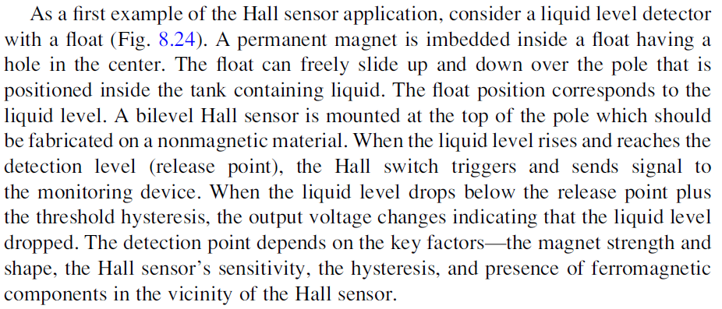

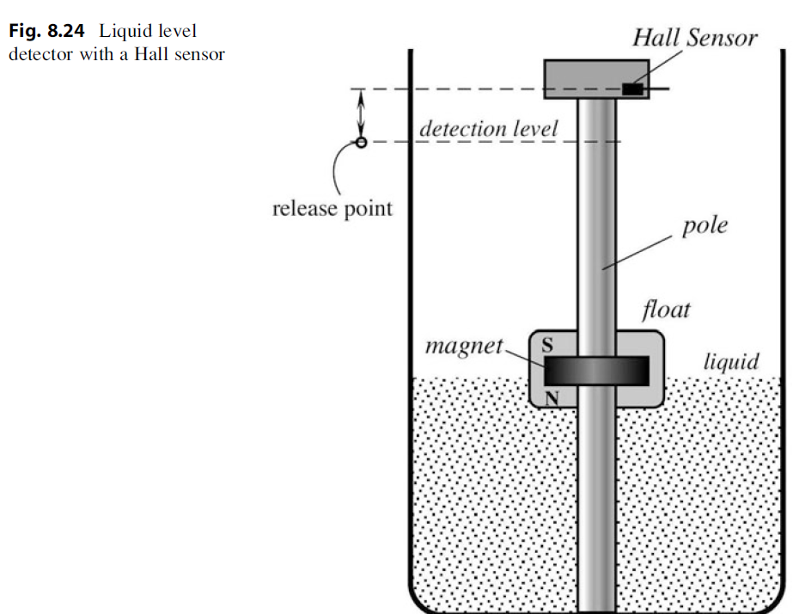

Suppose your liquid is distilled water. The magnet measures 100 gauss at the freezing point of 0°C, and decreases linearly to 90 gauss at 100°C. These measurements assume that the magnet is directly touching a ferritic object. As the distance between the magnet and object increases, the magnetic field sensed by the object drops accordingly.

Specify the proper unipolar switch from the reference “Data sheet for High Reliability Hallogic Hall-effect” by TT Electronics Inc. Given the data you find, what issue in the specs might prevent this device from working properly?

Answer:

**OMH090** [**[19]**](http://www.ttelectronics.com/sites/default/files/download-files/OMH090-3075_B-S_RevK-1.pdf)

From the following figure, nominal values can be determined

Operating point at 0°C – 90 gauss

Releasing point at 0°C – 70 gauss

Operating point at 100°C – 80 gauss

Releasing point at 100°C – 55 gauss

From the datasheet, it can be found out that **the maximum values of both, operating point and releasing point are more than 100 – which can prevent this switch to ever shutting off.**

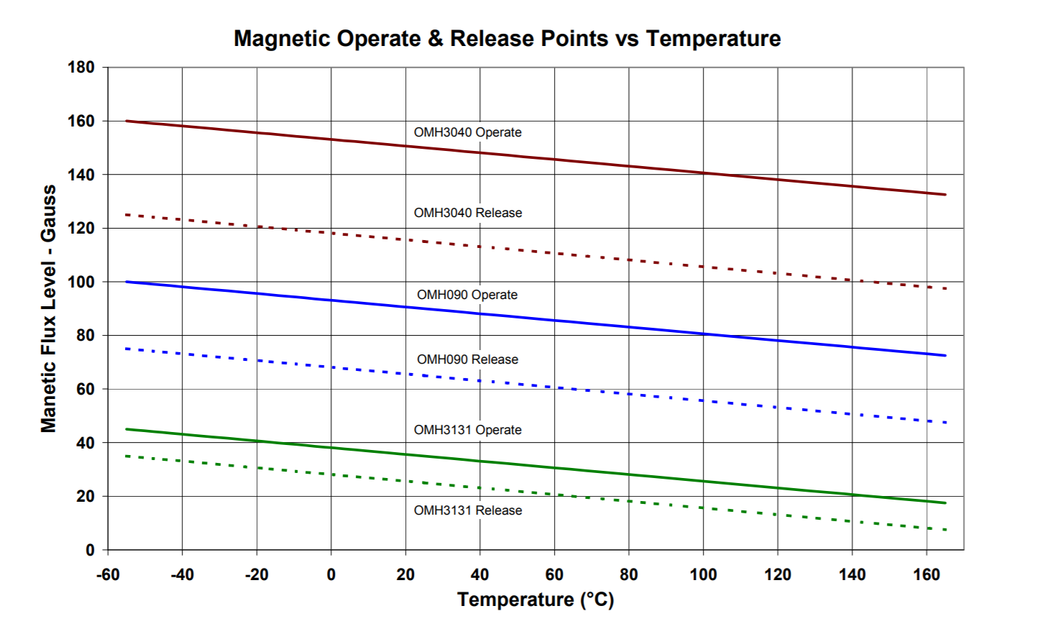

1. An eddy current sensor is used to detect the presence of an automobile at a gate. The sensor is pointed towards the front-left side fender of the automobile as it nears the gate.

The frequency of the induced electromagnetic field is 10,000 hz. Assume the electrical conductivity of an automobile can be modelled as that of carbon steel piano wire.

How far into the fender will the eddy currents be induced? Specify a one-decimal point answer in millimeters.

Answer: **1.903mm**

Spring steel (aka carbon steel which is used for piano wire) – conductivity [**[20]**](https://en.wikipedia.org/wiki/Electrical_resistivity_and_conductivity#Resistivity_and_conductivity_of_various_materials)

Permeability of free space – [**[21]**](https://whatis.techtarget.com/definition/permeability-of-free-space-a-vacuum)



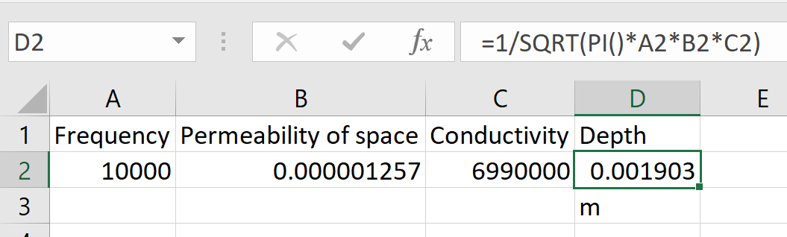

1. Answer the following questions about accelerometers.

J.1 What is the resonance frequency of an accelerometer? How does this frequency relate to the highest frequency that the sensor can measure?

Answer: **Resonance** **frequency** of an accelerometer is the **frequency at which, the output and sensitivity – both are at maximum**. it is the result of the natural resonance of the mechanical structure of the accelerometer itself. Since it **induces** **large** **positive** **error, it sets the upper limit on the sensor that can be measured** [**[22 – page 4]**](https://endevco.com/news/emails/2011_12/tp328.pdf) **.**

J.2 What type of accelerometer is the Analog Devices ADXL1001/1002? (Pick from the technologies described in slide decks C3M3V5, V6, and V7) How do you know this?

Answer: **MEMS Differential Capacitive Accelerometer**

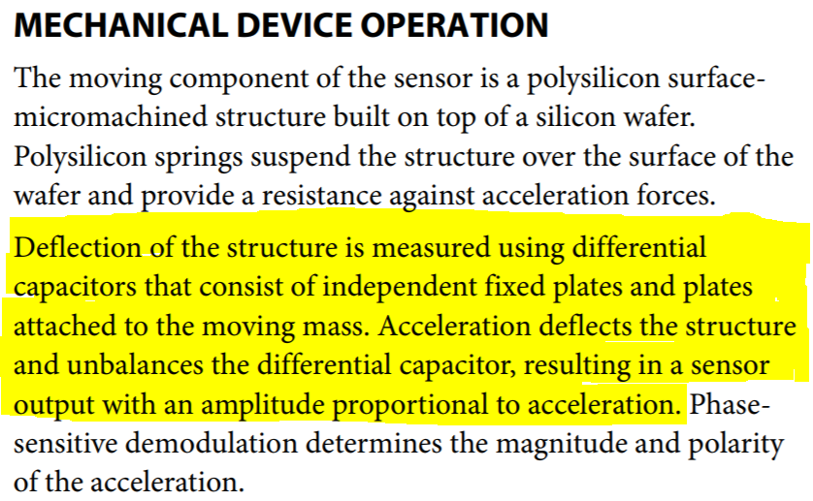

The highlighter portion clearly points to the mentioned type of accelerometer.

J.3 Page 7 of the ADXL 1001 sensor spec sheet gives this bar chart below. Based solely on this data, what is an estimate for the sensitivity and worst case tolerance?

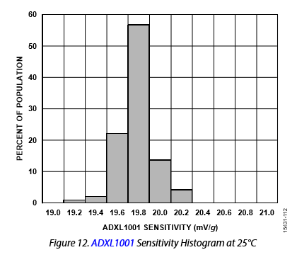

Answer: Sensitivity can be calculated by taking **weighted** **average**.

Thus, **sensitivity** = (0.02*19.2) + (0.03*19.4) + (0.22*19.6) + (0.56*19.8) + (0.13*20.0) + (0.04*20.2) = **19.774.**

**Tolerance** **1** = ((19.2 – 19.774) / 19.774) * 100% = **-2.90%**

**Tolerance** **2** = ((20.2 – 19.774) / 19.774) * 100% = **2.15%**

**Total value of tolerance = 5.05%**

J.4 How does a piezoelectric accelerometer determine acceleration? What is the most basic equation that governs its operation, and what famous scientist postulated this equation? (Hint: he was also a famous mathematician)

Answer: A **piezoelectric accelerometer consists of a mass attached to a piezoelectric crystal** which is mounted on a case. **When** the accelerometer body is subjected to **vibration**, **the mass on the crystal remains undisturbed in space due to inertia**. **As a result, the mass compresses and stretches the piezoelectric crystal**. **This force is proportional to acceleration in accordance with Newton’s second law, F = ma, and generates a charge.** The charge output is then converted into low impedance voltage output with the help of electronics [**[23]**](https://www.azosensors.com/article.aspx?ArticleID=309) . **Most basic equation – F = m*a**

**Scientist - Newton**

J.5 What equation is used to determine the magnitude of the displacement in this diagram of a capacitance accelerometer? What is a simple formula you can use to relate the magnitude of the displacement to that of the acceleration?

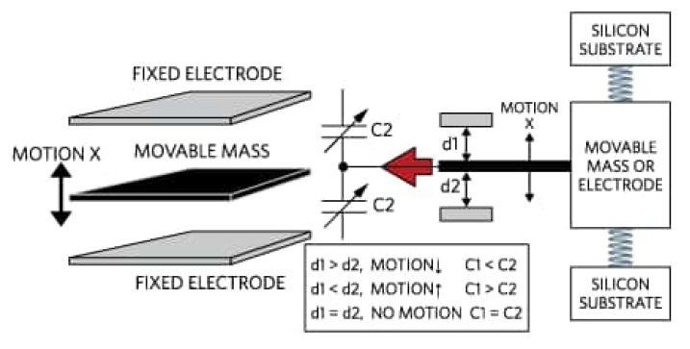

Answer: Equation to determine the magnitude of the displacement –

**C = (ε*A) / d**, where C is capacitance, ε is dielectric constant, A is area, and d is the distance between plates. Since the ε and A are constant in this situation, capacitance is inversely proportional to the magnitude of the displacement [**[24]**](http://boomeria.org/labsphys/physlabook/lab13.pdf) .

Using Hooke’s law – F = k*d [**[25]**](http://engineering-sciences.uniroma2.it/MENU/DOC/TESI/2013/2013_tesi%20NISTICO%20Andrea.pdf) , and we already have F = m*a thus,

**d = (m*a) / k**.

J.6 What are the advantages and disadvantages of using quartz vs. ceramic for the measuring element in a piezoelectric accelerometer?

Answer: [**[26]**](http://www.modalshop.com/calibration.asp?ID=194)

**Advantages** of Quartz

* + - Naturally piezoelectric.
    - Best long-term stability
    - No pyro electric output and it has a small and stable thermal coefficient
    - High Voltage output
    - High open circuit sensitivity

**Disadvantages** of Quartz

* Not appropriate to use at high temperatures
* Somewhat higher noise floor in voltage operation
* Limited cuts and geometry

J.7 What are three ceramic materials that are used to create piezoelectric accelerometers? What is their chemical composition?

Answer: Earlier, **ZnO (Zinc Oxide)** [**[27]**](https://onlinelibrary.wiley.com/doi/full/10.1111/j.1551-2916.2008.02421.x)was used to create piezoelectric accelerometer. Currently, most widely used material is **PZT (Lead Zirconate Titanate – PbZr0.53Ti0.47O3)** [**[28]**](https://www.ceramtec.com/ceramic-materials/piezo-ceramics/basics/)**.** Also, there is a lead free option – which is known as **Sodium Bismuth Titanate (Bi0.5Na0.5TiO3)** [**[29]**](https://www.piceramic.com/en/products/piezoceramic-materials/)**.**

J.7 The picture below is a diagram of a MEMS gyroscope. What causes the proof mass to vibrate in the x-direction?

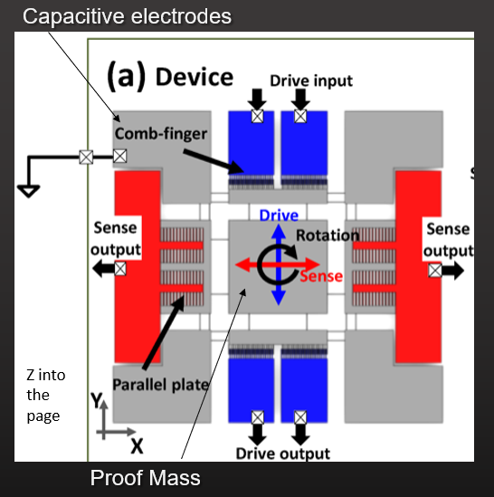

Answer: The **Coriolis force** Fc causes the sensor to vibrate in the X direction

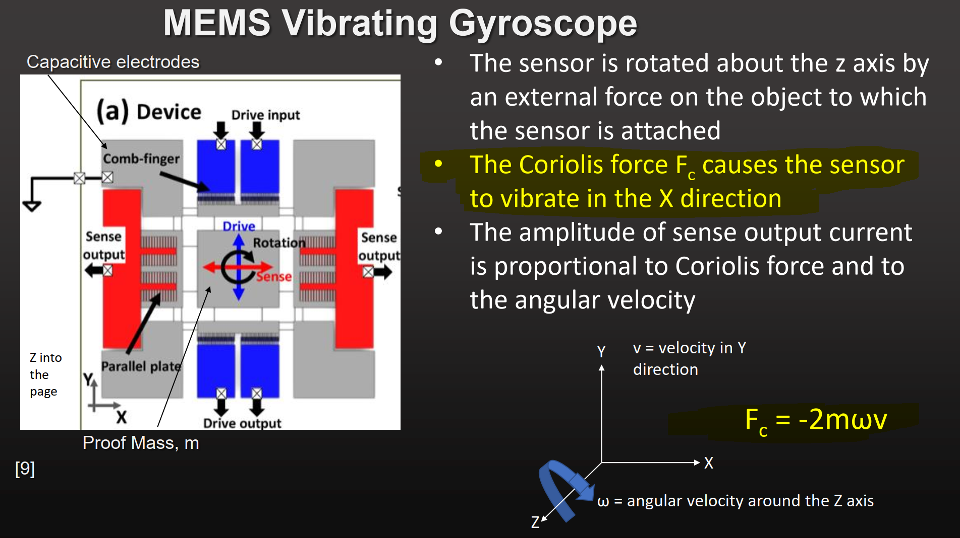

1. An accelerometer is measuring a structure as described below:



What is the percentage error in the accelerometer at the highest frequency it can measure? (Type in a two-decimal number)

Answer: Using these equations to get necessary values –

ζ = (c/2) / √(km), ωn = √(k/m), ω = 2*π*f

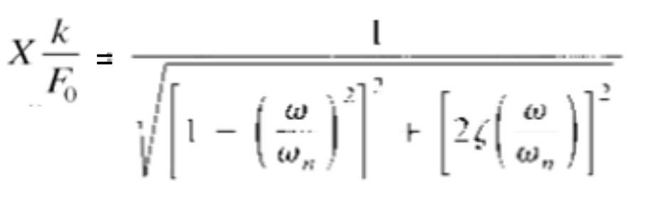

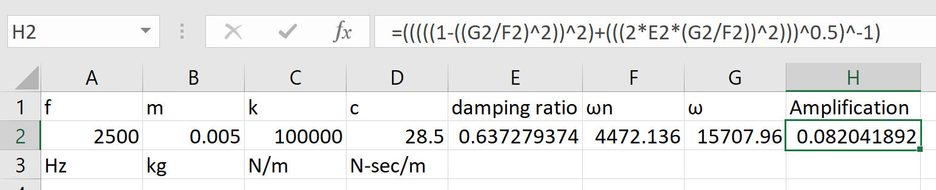

Thus X*(k/Fo) = amplification factor = 0.08204 (value of 1 would mean no loss). This means that the signal is suffering from heavy loss since only the 8.2% of the output/magnitude is being made available. Thus, the error = 100% – 8.204% = **91.796%**

1. You are using the Analog Devices ADXL1001 accelerometer with the specifications given by this screenshot below. You are using the accelerometer at the nominal ambient temperature of 25°C. Therefore, you can ignore errors due to ambient temperature.

However, you need to calculate the error in g’s due to

* Spurious accelerations on the Y and Z axes (i.e. cross axis sensitivity)
* Noise density
* Response error due to frequency

Other data, not on the spec sheet, is given here in this table.



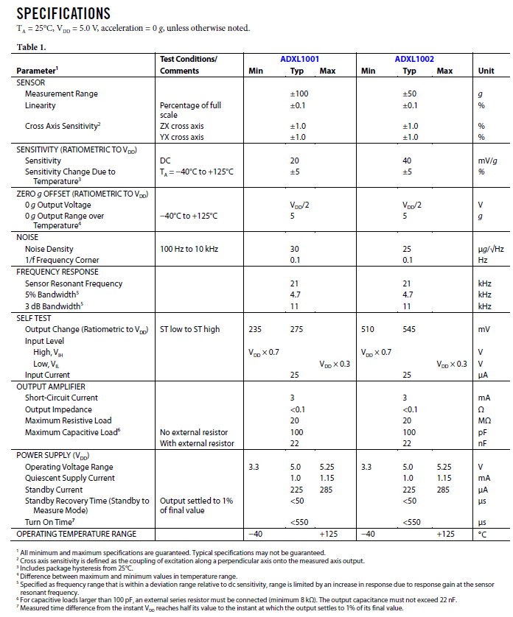

What is the total error in g’s in your measurement? (Type in a three -decimal number)

Answer:

1. **Cross Axis Sensitivity** – 1% of original sensitivity

Since that is 20mV/g, cross axis sensitivity will be 0.2mV/g

For Y – 5g, therefore output = 0.2mV/g * 5g = 1mV

For Z – 3g, therefore output = 0.2mV/g * 3g = 0.6mV

Total 1.6mV or 1.6mV / 20mV/g = **0.08g** due to cross axis sensitivity.

1. **Noise Density** - 30µg/√Hz

Since the frequency is 3000Hz, noise density =

30µg/√Hz * √3000Hz = 1.643mg = **0.001643g**

1. **Response Error due to Frequency**

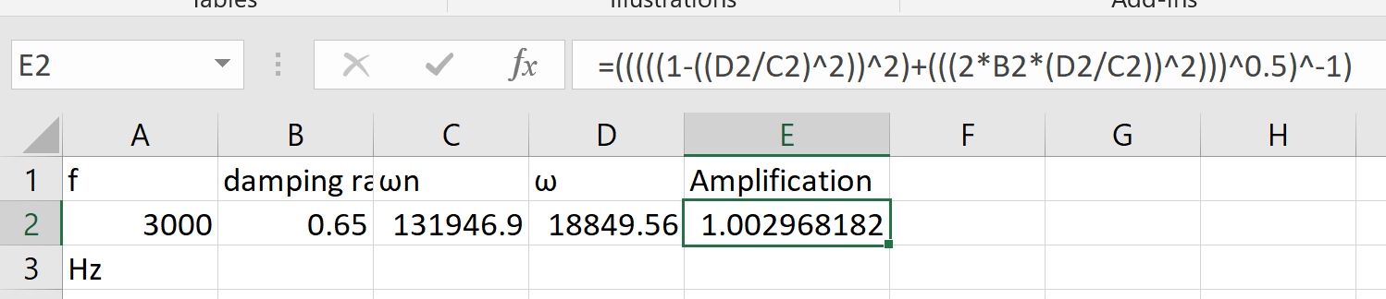

Amplification should be 1, but it is more than that so error =

1.002968 – 1 = 0.002968 = 0.2968%

Using the sensitivity and output, output value in g =

900mV / 20mV/g = 45g. Therefore, error = 0.002968 * 45g = **0.13356g**

**Total Error = 0.215203g**

1. You are using the Bruel and Kjaer type 4384 piezoelectric accelerometer to measure vibrations in a commercial jet engine. This is a very difficult environment for this accelerometer. The device is subject to the maximum error of the charge sensitivity at the vibrational frequency you are measuring. There is one silver lining. Because your vibrational frequency is so far below the natural frequency of the accelerometer, you can ignore error in the measurement per this equation below:

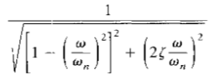

In addition, your device experiences vibration in the X, Y, an Z direction, even though you are only interested in the vibration in the X direction. Piezoelectric accelerometers are known to be subject to errors due to base strain and operating at elevated temperatures, and that is the case here. There is a magnetic field coming from other instruments nearby, and as always, the accelerometer has its own electrical noise.

Other data, not on the spec sheet, is given here in this table below:

Answer these three questions:

1. What is the total error in g’s in your measurement? (Type in a three -decimal number)
2. What is this error expressed as a % of the nominal X-axis acceleration?
3. Which sources of error are your top 3, expressed in order (i.e. first, second third highest sources)



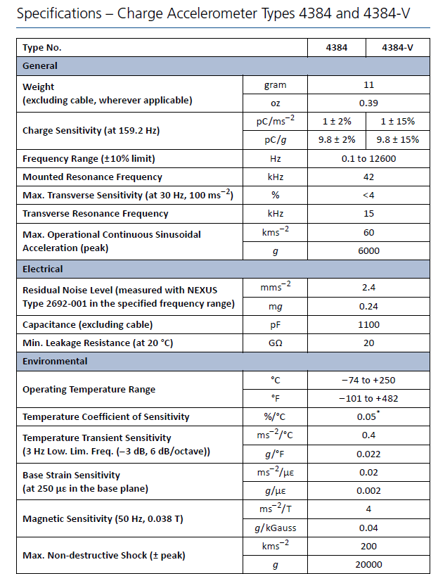

Answer:

1. **Charge Sensitivity** – max error – 9.8 - 2% pC/g

Measured charge is 2000pC. New sensitivity = 9.8*0.98 = 9.604

G due to nominal = 2000 / 9.8 = 204.0816 (reading – output)

G due to new sensitivity – 2000 / 9.604 = 208.2465

Error = difference between nominal and new =

208.2465 – 204.0816g = **4.1649g**

1. **Transverse Sensitivity** – taking max – 4%

18g – (9.8) *4%*18g = 7.056pC from Y

14g – (9.8) *4%*14g = 5.488pC from Z

Total charge = 12.544. Converting to g using new sensitivity =

12.544 / 9.604 = **1.3061g**

1. **Base strain** – 0.002g/µε

Given ε = 0.003 = 3000uε

Thus error = 3000 * 0.002 = **6g**

1. **Elevated temperature** – temperature transient not significant – [**[30 – page 7]**](https://www.bksv.com/media/doc/Bp0196.pdf)

Calibrated at 25°C but ambient is 100°C, thus difference of 75°C

Error in sensitivity due to elevated temperature = 0.05% * 75 = 3.75% This is error in nominal sensitivity (pC/g)

New sensitivity = (9.8*0.9625) = 9.4325 pC/g

Nominal g – 2000 / 9.8 = 204.0816g

New g – 2000 / 9.4325 = 212.0328

Error = **7.9512g**

1. **Magnetic field** – 0.04 g/kgauss

Given magnetic field = 1kgauss, thus error = **0.04g**

**Total Error = 19.4622g**

**Percentage = 9.5364% ((19.4622*100)/204.0816)**

**Top 3 Errors – Elevated Temperature > Base Strain > Charge Sensitivity**